EVOLUTION

Technical Summer School ‘25

WEEK 1

In this week, we will discuss different theories of evolution, the geological time scale, evidences of evolution and finally Darwinism and the Mutation theory.

**Origin of Life**

**What is *Life*, Fundamentally?**

Before understanding how life began, we must define what life is. Life is typically characterized by:

* **Metabolism** – the ability to use energy to perform work.
* **Growth and reproduction** – the ability to replicate and pass on traits.
* **Response to stimuli** – reacting to the environment.
* **Evolution** – changes in heritable traits over generations.
* **Cellular organization** – life as we know it is cell-based.

A living cell is an incredibly complex system. But life **did not start that way**. It likely **emerged gradually**, from simpler chemical systems.

Abiogenesis

Abiogenesis refers to the natural process by which life arises from non-living chemical substances. This theory posits that, under the right conditions, simple organic compounds can evolve into more complex molecules, eventually leading to the formation of primitive life forms.

**From Molecules to Life**

The transition from simple molecules to living organisms involves several steps:

1. **Formation of Monomers:** Simple organic molecules like amino acids and nucleotides form.
2. **Polymerization:** Monomers link to form polymers such as proteins and nucleic acids.
3. **Protobionts:** These polymers become enclosed within lipid membranes, forming cell-like structures.
4. **Self-Replication:** Some structures acquire the ability to replicate, leading to the first primitive life forms.

Oparin Haldane Theory

The **Oparin-Haldane theory** (also called the **primordial soup theory**) is one of the earliest and most influential scientific explanations for the **origin of life** on Earth. The core idea of this theory is that life originated from **non-living matter** through a **gradual chemical evolution** of carbon-based molecules under the **conditions of early Earth**.

**Early Earth had a reducing atmosphere**:

* Rich in **methane (CH₄), ammonia (NH₃), hydrogen (H₂),** and **water vapor (H₂O)**
* No free oxygen (O₂), which would have destroyed organic molecules
* Lots of **energy** from UV radiation, lightning, and volcanoes

**Simple molecules formed organic compounds**:

* Gases in the atmosphere reacted (with energy input) to form basic molecules like **amino acids, sugars, and nucleotides**

**Organic molecules accumulated in oceans**:

* Oceans became a "primordial soup" — a warm, nutrient-rich solution where chemical reactions took place over millions of years

**Formation of more complex molecules**:

* Simple molecules formed **proteins, nucleic acids**, and eventually **membrane-bound structures** called **coacervates** (primitive cell-like droplets)

**Chemical evolution led to life**:

* These early structures eventually gained the ability to **self-replicate**, leading to the first living cells

Miller Urey Experiment

The **Miller-Urey experiment** (1953) is one of the most famous experiments in the study of the **origin of life**. It provided **experimental support** for the **Oparin-Haldane theory** by demonstrating that **organic molecules**, like **amino acids**, could form **spontaneously** under conditions simulating early Earth.

**Setup of the Experiment:**

They built an apparatus to simulate early Earth's environment:\

* **Flask with Water (H₂O):**
  + Represented the **primordial ocean**
  + Boiled to produce water vapor
* **Chamber with Gases:**
  + Mixture of **methane (CH₄), ammonia (NH₃), hydrogen (H₂),** and water vapor
  + Mimicked Earth’s **reducing atmosphere** (no oxygen)
* **Electric Spark:**
  + Simulated **lightning** — a source of energy
* **Cooling and Condensation:**
  + A condenser cooled the vapor, allowing it to condense and cycle back, mimicking rain

**What Happened?**

* The system ran continuously for **a week**
* Chemical reactions occurred in the gas chamber due to the **electric sparks**
* Liquid at the bottom turned **reddish-brown**

**Results:**

They **detected** the formation of **several organic compounds**, including:

* **Amino acids** like **glycine**, **alanine**, etc.
* These are the **building blocks of proteins**, essential for life

 This showed that **complex organic molecules** could be made **from simple gases and energy — no life needed**.

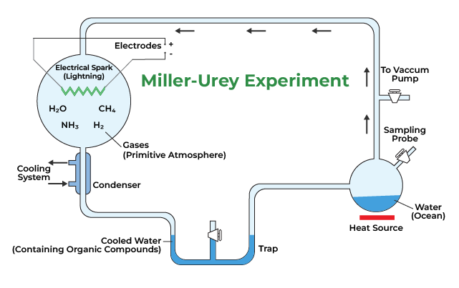

Some videos that you can refer for the above topics:

* [Abiogenesis](https://youtu.be/QuClvCOwVpQ?feature=shared)
* [Oparin Haldane Theory](https://youtu.be/l9ePZtZdKG4?feature=shared)
* [Miller Urey Expt](https://youtu.be/20cHsyGIkSU?feature=shared)

Chemical Evolution

According to this theory, life originated on earth by combinations of several chemicals through constant chemical reactions over a long period of time. This theory is also called self assembly theory of origin of life or biochemical origin of life. This theory was first formulated by Haeckel but later developed by the Russian scientist Alexander I. Oparin (1924) and British biologist J. B. S. Haldane (1929). The process of chemical evolution can be divided into following steps :

1. **The Early Earth and Its Primitive Atmosphere:** Imagine our planet forming about 4.6 billion years ago, not as the welcoming blue sphere we know, but as a hot, swirling cloud of gases and dust. As it cooled, heavier elements sank to the core, while lighter ones formed the early atmosphere. This early atmosphere was crucial – it was a **reducing atmosphere**, practically **devoid of free oxygen** (O2​) .
2. **The Formation of Ammonia, Water, and Methane:** In this hot, early environment, the abundant and reactive hydrogen readily combined with other elements, leading to the formation of key molecules like methane (CH4​), ammonia (NH3​), water (H2​O), and hydrogen sulfide (H2​S). These were the fundamental building blocks.
3. **The Birth of Simple Organic Molecules:** As the Earth cooled and water vapor condensed into rain, forming the first water bodies, a crucial factor came into play: the lack of an ozone layer. This meant intense ultraviolet (UV) radiation, along with lightning and volcanic activity, bombarded the planet. This energy fueled reactions between the simple atmospheric gases, leading to the creation of the first simple organic molecules – things like monosaccharides, amino acids, purines, pyrimidines, fatty acids, and glycerol. These molecules accumulated in the early oceans, forming Haldane's famous "hot dilute soup" or "primitive broth," a stable environment for further reactions due to the absence of free oxygen and degrading enzymes.
4. **From Simple to Complex: The Rise of Macromolecules:** Within this primordial soup, the simple organic molecules began to link together through polymerization. Amino acids formed proteins, sugars formed polysaccharides, and fatty acids and glycerol formed lipids. The formation of proteins, particularly enzymes, was a pivotal moment, as these molecules could now catalyze and speed up further chemical reactions.
5. **The Dawn of Heredity: Formation of Nucleic Acids:** Next came the assembly of nucleic acids – RNA and DNA – from nucleotides, which themselves formed from sugars, phosphate, and nitrogenous bases. The development of self-replication in these nucleic acids, likely starting with RNA, was a monumental step towards life.
6. **Protobionts Emerge: The Precursors to Cells:** The complex organic molecules then began to self-assemble into organized structures called protobionts or procells. Oparin described these as **coacervates**, while Sidney Fox called them **microspheres** or proteinoids. These were essentially collections of organic molecules enclosed within a boundary, exhibiting some life-like properties such as growth and division, although they weren't truly alive. 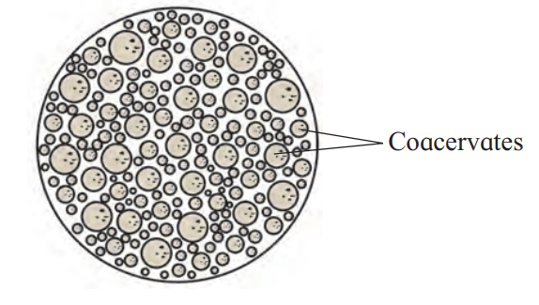

Coacervates and microspheres were non-living colloidal aggregations of lipids and proteinoids respectively. They had some basic properties of living cells, such as growth and division. These colloidal aggregations turned into first primitive living system called eobionts or protocell.

1. **The First True Cell Arises:** The final major step was the encapsulation of a self-replicating genetic system (initially likely RNA) within these protocells, leading to the first true cells. These early cells were probably anaerobic, heterotrophic, and obtained energy by consuming the organic molecules around them.

The **Urey-Miller experiment** provided compelling early evidence for this theory, demonstrating that amino acids and other organic molecules could indeed form spontaneously under simulated early Earth conditions.

And the **RNA World Hypothesis** offers a fascinating glimpse into the early stages of life, suggesting that RNA, with its dual ability to carry genetic information and catalyze reactions, may have been the primary molecule of life before the evolution of DNA and proteins took over their specialized roles.

RNA World Hypothesis

This influential hypothesis suggests that RNA, rather than DNA and proteins, was the primary genetic material and catalytic molecule in early life. RNA possesses both information storage and enzymatic capabilities.

Before DNA and proteins, **RNA** did both:

* **Stored information** (like DNA).
* **Catalyzed reactions** (like enzymes).

These RNA molecules are called **ribozymes**.

Eventually, DNA likely took over the role of primary genetic storage due to its greater stability, and proteins became the dominant catalytic molecules due to their greater structural diversity.

Some videos you can refer on chemical evolution and RNA World Hypothesis:

* [Synthesis of Prebiotic Molecules](https://youtu.be/-O6ba6lnBcw?feature=shared)
* [RNA world hypothesis](https://youtu.be/K1xnYFCZ9Yg?feature=shared)

Geological Time Scale

The **Geological Time Scale** is a **chronological framework** that scientists use to **organize and interpret Earth's history**. It records the **sequence of geological, biological, and climatic events** that have occurred over Earth’s **4.6 billion-year** existence.

Think of it as a **calendar** for the Earth’s history — but instead of days and months, it’s divided into **eons, eras, periods, epochs, and ages**, based on major events like the formation of continents, extinction of species, and the appearance of new life forms.

**Why Is the GTS Important?**

* Helps geologists **date rocks and fossils**
* Allows paleontologists to **trace the evolution** of life
* Provides a context for **mass extinctions**, **ice ages**, and **continental drift**
* Aids in studying **climate changes** over millions of years

**Structure of the Geological Time Scale**

**1. Eons – The largest divisions (hundreds of millions to billions of years)**

|  |  |  |
| --- | --- | --- |
| **Eon** | **Time Range** | **Highlights** |
| **Hadean** | ~4.6 – 4.0 billion years ago | Earth forms; no solid crust yet |
| **Archean** | ~4.0 – 2.5 billion years ago | First simple life (prokaryotes) |
| **Proterozoic** | ~2.5 – 541 million years ago | Oxygen build-up; first complex cells |
| **Phanerozoic** | 541 million years ago – now | Visible life; complex plants and animals |

**2. Eras – Subdivisions of eons (tens to hundreds of millions of years)**

Only the **Phanerozoic Eon** is divided into **3 major eras**:

|  |  |  |
| --- | --- | --- |
| **Era** | **Time Period** | **Major Events** |
| **Paleozoic** | 541 – 252 Mya | Cambrian Explosion; fish, amphibians, insects |
| **Mesozoic** | 252 – 66 Mya | Age of Dinosaurs; first birds and mammals |
| **Cenozoic** | 66 Mya – Present | Age of Mammals; human evolution, ice ages |

The Eras are further divided into Periods which are then divided into Epochs and Ages.

Some videos to refer for Geological Time Scale:

* [Brief of Earth's geological time scale](https://youtu.be/XMjkO72KVjE?feature=shared)
* [Earth's evolution](https://youtu.be/LinWJsangs4?feature=shared)

**Evidences of Evolution:**

* **Fossils**
  + The study of ancient life with the help of fossils is called Palaeontology.
  + Fossils are the remains of organisms for a million years of years ago which are found in rocks.
  + There are three ways in which fossils are formed.
  + Fossils can form when parts of organisms have not decayed, this occurs due to the absence of conditions needed to decay.
    - Too cold temperature.
    - Lack of oxygen supply.
    - Not enough water supply.
  + Fossils can form even if an organism decays if parts of the organisms are slowly replaced by the minerals during the decay process.
  + Fossils can be the preserved traces of organisms.
  + Fossils that exhibit characteristics of two different groups, acting as evolutionary links.
  + Indicate the evolutionary transition between major vertebrate groups.
  + Examples:
    - Seymouria – Transition between amphibians and reptiles.
    - Archaeopteryx – Transition between reptiles and birds.
* **Earth’s Fossil Record:**
  + Archaeopteryx:
    - A Jurassic-era fossil of a crow-sized, toothed bird found in Germany.
    - Regarded as the "missing link" between reptiles and birds due to shared characteristics from both groups.
  + **Reptilian Characters of Archaeopteryx:**
    1. **Long bony tail** – Unlike the pygostyle in modern birds.
    2. **Clawed digits on forelimbs and hind limbs** – Three distinct claws like reptiles.
    3. **Scales on body** – Especially on legs and tail.
    4. **Single-headed ribs** – Primitive rib structure.
    5. **Abdominal ribs (gastralia)** – Seen in crocodiles and dinosaurs.
    6. **Homodont teeth** – All teeth similar in shape; modern birds lack teeth.
    7. **Sternum without keel** – No strong keel for flight muscle attachment.
    8. **Solid (non-pneumatic) bones** – Unlike the hollow bones of birds.
  + **Avian (Bird-like) Characters of Archaeopteryx:**
    1. **Feathers** – Complex feathers on wings and tail.
    2. **Forelimbs modified into wings** – Capable of gliding or weak flight.
    3. **Beak-like snout** – Partial jaw modification despite still having teeth.
    4. **Fused skull bones** –Lightweight and rigid skull structure.
    5. **Large, rounded cranium** – Suggests a relatively larger brain.
    6. **Single occipital condyle** – Skull-spine joint similar to birds.
    7. **Bird-like limb bones** –Proportions resemble modern perching birds.
    8. **Opposable first toe** – Adapted for perching.

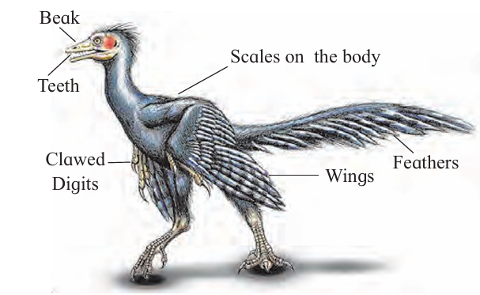

* **Comparative Anatomy:**
  + Structurally similar organs with different functions are called Homologous organs.
  + **Examples:**

1. Forelimbs of vertebrates (lizards, birds, bats, horses, whales, humans):
   * + - Same bones: humerus, radius-ulna, carpals, metacarpals, phalanges.
       - Different functions: flying (birds), swimming (whales), grasping (humans), etc.
     + Vertebrate heart and brain:
       - Originate from same embryonic structures.
       - Similar internal structure across species.
       - Vary in complexity and function.
     + In plants:
       - horns of Bougainvillea and tendrils of Cucurbita.
       - Thorns of Bael and tendrils of passion flower.
       - Modified from the same organ type but with different functions.
       - 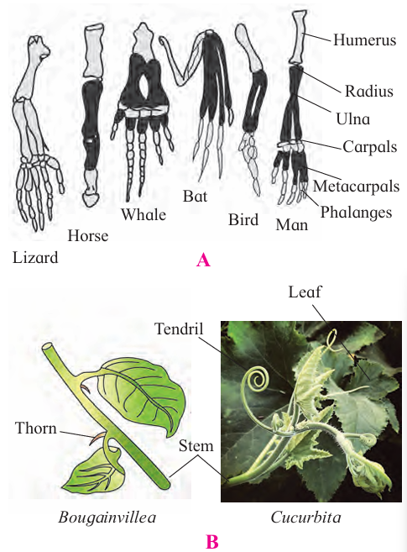
   * Analogous organs are those which are structurally dissimilar but functionally similar.
   * **Examples:**
     + Eyes of octopus (mollusc) and mammals:
       - Similar function (vision).
     + Flippers of penguins (birds) and dolphins (mammals):
       - Function: swimming.
     + Sweet potato (root) and potato (stem):
       - Both store starch
     + Tendrils in pea (terminal leaflets) and vitis (apical bud):
       - Same function (climbing)
   * Vestigial organs are imperfectly developed and non-functional, degenerate structures which were functional in some related and other animals or in ancestors.
   * **Examples:**
     + Vestigial nictitating membrane:
       - Reduced third eyelid; functional in some animals
     + Wisdom teeth (third molars):
       - Often non-functional or removed
     + Coccyx (tail bone):
       - Remnant of a tail, unused due to erect posture
     + Vermiform appendix and caecum:
       - Functional in herbivores for digesting cellulose
       - Largely useless in humans due to diet

* **Embryology:**
  + Embryology is the branch of biology that studies the formation, growth, and development of embryos from fertilization to fetal stage.
  + Helps understand developmental processes in organisms.
  + Provides strong evidence for organic evolution through embryological similarities.
  + Supports the idea of common ancestry.
  + **Evidence from Embryology(Recapitulation Theory):**
    - Proposed by **Ernst Haeckel**.
    - Statement:

"Ontogeny recapitulates phylogeny"

→ The development of an individual organism (ontogeny) mirrors the evolutionary history of its species (phylogeny).

* + - Many animals show similar embryonic stages, despite being very different as adults.
    - This suggests descent from a common ancestor.
    - **Examples:**
      * Human embryo features:
        + Pharyngeal gill slits: Similar to those in fish; later become Eustachian tubes in humans.
* Post-anal tail: Similar to other vertebrates; becomes the coccyx in humans. **ORGANIC EVOLUTION**
* Organic evolution refers to the gradual development and diversification of life on Earth from earlier, simpler forms over billions of years. It explains how present-day organisms are connected through a massive evolutionary tree stemming from a common ancestor.
* Descent with Modification (Darwin's Core Idea)
* Offspring inherit traits from parents, but not identically.
* Small variations accumulate over generations.
* Leads to gradual changes in species.
* Descent with Modification (Darwin's Core Idea)
  + Offspring inherit traits from parents, but not identically.
  + Small variations accumulate over generations.
  + Leads to gradual changes in species.
* Descent with Modification (Darwin's Core Idea)
* Offspring inherit traits from parents, but not identically.
* Small variations accumulate over generations.
* Leads to gradual changes in species.
* Natural Selection (Proposed by Darwin & Wallace)
* Variation: Individuals show differences in traits.
* Inheritance: Many traits are genetically passed to offspring.
* Overproduction: More offspring are produced than can survive.
* Differential Survival and Reproduction:
  + Individuals with advantageous traits survive better and reproduce more.
  + These traits become more common over time.
  + Leads to adaptation and evolution of populations.
* Other Mechanisms of Evolution:
* Mutation: Random changes in DNA; source of new variation.
* Gene Flow: Movement of genes between populations (migration)
* Genetic Drift: Random changes in allele frequencies; more impactful in small populations
* Speciation: Formation of new species via reproductive isolation and divergence.
* Theories and Experiments:
* Lamarck’s Theory (Inheritance of Acquired Characters)
* Traits developed by use or disuse can be passed to offspring.
* Example: Giraffes' long necks evolved from stretching.
* Disproved by August Weismann:
* Cut off tails of rats for 21 generations.
* No offspring showed tail reduction.
* Concluded: Acquired traits (somatic changes) are not inherited.
* Weismann’s Theory: Continuity of Germplasm
* Introduced a key distinction:
  + Somatoplasm: Body cells – changes here not inherited.
  + Germplasm: Reproductive cells – only these changes are passed on.
* Variations in germ cells lead to evolutionary change.
* **Darwinism**
* Darwinism refers to the theory of biological evolution developed by Charles Darwin, emphasizing natural selection as the primary mechanism driving the evolution of species.
* Principles of Darwinism (from On the Origin of Species, 1859):
* **Variation**
  + Individuals in a population differ in physical traits.
  + Example: Beak shapes of Galapagos finches.
* **Inheritance**
  + Traits are passed from parents to offspring.
  + Darwin lacked knowledge of genes but observed patterns of inheritance.
* **Overproduction**
  + Organisms produce more offspring than can survive.
  + Leads to competition for resources.
* **Natural Selection (Survival of the Fittest)**
  + Individuals with advantageous traits are more likely to survive and reproduce.
  + These traits increase in frequency over generations.
* **Descent with Modification**
  + Over time, species change and diverge from common ancestors.
  + All life shares a common evolutionary lineage.

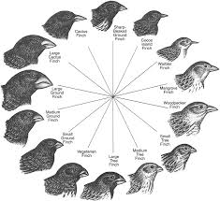

* **The Modern Synthesis (Neo-Darwinism)**
* Developed in the early 20th century, this integrated Darwin's theory with advances in genetics.
* Key Additions to Darwinism:
* **Genetic Basis of Variation:** Variation arises due to mutations and genetic recombination.
* **Mendelian Inheritance:** Traits are inherited according to Mendel’s laws (dominant/recessive).
* **Population Genetics:** Studies changes in gene frequencies over time in populations.
* **Mathematical Models:** Evolution can be modeled and quantified (e.g., Hardy-Weinberg equilibrium).
* **Peppered Moth (Biston betularia)**
* Evidence for Natural Selection.
* Species: Peppered moth (Biston betularia)
* Two color forms:
  + Light-colored (typica) – Pale body with dark speckles.
  + Dark-colored (carbonaria) – Almost black (melanic form).
* **Before Industrial Revolution:**
* Trees were covered in light-colored lichens.
* Light-colored moths were camouflaged; dark moths stood out and were eaten by birds.
* Result: Light-colored moths were more common.
* **During/After Industrial Revolution:**
* Soot pollution darkened tree bark and killed lichens.
* Now, dark-colored moths were better camouflaged, while light ones were easily spotted and eaten.
* Result: Dark-colored moths became more common, especially in polluted areas.
* **After Clean Air Acts:**
* Air quality improved, trees became lighter again.

Light-colored moths resurged in population

**Video references:**

[*https://youtu.be/P5a3dAUod38?feature=shared*](https://youtu.be/P5a3dAUod38?feature=shared)

[*https://youtu.be/2f38r4qKkLw?feature=shared*](https://youtu.be/2f38r4qKkLw?feature=shared)

[*https://youtu.be/qIVVU_fbAeA?feature=shared*](https://youtu.be/qIVVU_fbAeA?feature=shared)

[*https://youtu.be/pybhlOhXkiM?feature=shared*](https://youtu.be/pybhlOhXkiM?feature=shared)

[*https://youtu.be/0SCjhI86grU?feature=shared*](https://youtu.be/0SCjhI86grU?feature=shared)

[*https://youtu.be/jI9IdqRdOb8?feature=shared*](https://youtu.be/jI9IdqRdOb8?feature=shared)

**MUTATION THEORY**

1. **Introduction:**

**Proposed by:** Hugo de Vries, a Dutch botanist, in the early 1900s.

**Based on:** Observations in the **Evening Primrose plant** (Oenothera lamarckiana), where he saw sudden changes in plant traits.

**Main idea**: Evolution doesn’t always happen slowly. Sometimes, it **happens suddenly due to changes in the genes, called mutations.**

2. **What is a Mutation?**

* A mutation is a sudden, random change in the DNA (genes) of an organism.
* DNA carries the instructions for how an organism looks and works. A small change in DNA can lead to a big difference in the organism.

**Example**: A normally red flower blooms in yellow; a human is born with an extra finger.

**EXPERIMENTS OF DEVRIES**

* Devries observed mutations in Oenothera Lamarckiana.
* He conducted breeding experiments in that plant. Devries collected the seeds of 0. lamarckiana and sowed the seeds in his field. After some time, he observed four new varieties of plants in addition to the parent variety.
* They are oenothera-mutations

i. **0. zygas** : It is taller than the parent.

ii. **0. nanella** It is shorter than the parent.

iii. **0. livifolia** : It contains more number of leaves than the parent.

iv. **0. brivistylis** : It contains shorter style than the parent.

* Devries cross pollinated the four new varieties and parent variety.
* He got few more new varieties. Devries continued the experiment for about ‘7’ generations. He got 50,000 plants. These 50,000 are 800 varieties. When these varieties were self pollinated, Devries got the same plants. Based on the above experiment, he proposed some observations. They are
* 3.**Key Features of Mutation Theory**

i. **Sudden Changes:**

Mutations are not gradual or step-by-step.

They appear suddenly in a single generation.

ii. **Mutations are Heritable:**

These changes are passed on to the next generation if they occur in reproductive cells (like sperm or egg cells).

iii. **Large Effects:**

The changes caused by mutations can be big, like a new flower color or a new leaf shape.

iv. **Source of New Species:**

According to de Vries, these sudden mutations **can create new species quickly**, unlike Darwin's idea of slow evolution.

v. **Random and Unpredictable:**

Mutations happen by chance and are not caused by need or environment.

4. **Causes of Mutations**

Mutations can be caused by natural internal errors or by external factors. These are divided into Natural Causes and Artificial (External) Causes:

i. **Natural Causes (Spontaneous Mutations)**

These mutations occur without any outside influence. They are part of natural biological processes.

a. **Errors during DNA replication**

Every time a cell divides, it copies its DNA.

Sometimes, the enzymes that do the copying make mistakes — a base might be added, deleted, or replaced.

Although cells have “proofreading” systems, some errors escape correction and become permanent mutations.

b. **Radiation from natural sources**

The sun gives off UV (ultraviolet) rays, which can damage the DNA in cells.

Cosmic rays from space can also penetrate Earth and affect living organisms.

These rays can cause breaks or changes in DNA strands, leading to mutations.

**c. Natural chemicals inside the body**

* Our own cells produce certain chemicals during metabolism.
* Some of these chemicals can accidentally react with DNA, causing structural changes or copying mistakes.
* For example, reactive oxygen species (ROS) can damage DNA bases.

ii. **Artificial/External Causes (Induced Mutations)**

These are mutations caused by outside agents, often in the environment or laboratory.

a. **Exposure to harmful chemicals (mutagens)**

* Certain industrial or lab chemicals, like benzene or formaldehyde, can directly damage DNA.
* Pesticides, cigarette smoke, and even some preservatives can act as mutagens.
* These chemicals may bind to DNA or cause faulty copying during replication.

b. **X-rays and other ionizing radiation**

* Medical X-rays or nuclear radiation can break DNA chains or remove DNA bases.
* High doses of ionizing radiation (like gamma rays) are especially harmful and can cause severe mutations or cancer.
* These are used in labs to induce mutations for study, but in nature, they are rare and dangerous.

c. **Viruses inserting their DNA into host cells**

* Some viruses, like HPV (Human Papillomavirus) or HIV, can insert their genetic material into the DNA of the host.
* When this happens, it can disrupt normal genes or activate dangerous ones (like cancer-causing genes).
* This kind of mutation is a biological **mutagen effect.**

5. **Types of Mutations**

i. **Beneficial Mutations**

Help the organism survive better.

**Example**: A plant developing drought resistance.

ii. **Harmful Mutations**

Cause diseases or defects.

**Example**: Genetic disorders like cystic fibrosis or sickle cell anemia.

iii. **Neutral Mutations**

Have no noticeable effect on the organism.

6. **Differences Between Mutation Theory and Darwin’s Theory.**

|  |  |  |
| --- | --- | --- |
| **Feature** | **Darwin’s Natural Selection** | **Hugo de Vries’ Mutation Theory** |
| Nature of change | Slow, small, continuous | Sudden, large, discontinuous |
| Source of change | Natural variation + environment | Random mutation |
| Role in evolution | Gradual development over time | Sudden appearance of new species |
| Importance of selection | Very important | Less important |

7. **Examples of Mutation in Real Life**

* Animals: A sheep born with short legs (used to make it easier to catch).
* Humans: Blue eyes or lactose tolerance from ancient mutations.
* Plants: A banana plant developing seedless fruit.
* Bacteria: Gaining resistance to antibiotics through genetic mutation.

8. **Importance of Mutation Theory in Modern Science**

* Helped develop modern genetics.
* Basis for biotechnology, gene therapy, and GMO crops.
* Helps understand genetic disorders.
* Plays a key role in evolutionary biology and molecular biology.

9**. Limitations of Mutation Theory**

* Most mutations are harmful or useless.
* De Vries focused only on large mutations, but most real-world evolution happens due to small mutations too.
* Today, scientists accept a combined theory: mutations create variations, and natural selection decides which survive.

**SUMMARY TABLE :**

|  |  |  |
| --- | --- | --- |
| **Cause Type** | **Source** | **How it causes mutation** |
| Natural – DNA replication errors | Inside the cell | Mistakes during DNA copying |
| Natural – Radiation | Sunlight, cosmic rays | Damages or changes DNA |
| Natural – Cellular chemicals | Body metabolism | Reacts with DNA, causes damage |
| Artificial – Chemicals | Pollution, smoke, industry | Binds or breaks DNA |
| Artificial – Radiation | X-rays, nuclear exposure | Cuts or alters DNA strands |
| Artificial – Viruses | Viral infections | Inserts foreign genes into DNA |

10. **Conclusion**

* Mutation Theory added a new dimension to the study of evolution.
* It showed that sudden genetic changes can play a major role in evolution.
* Though not fully correct on its own, it became an important part of the modern understanding of evolution when combined with Darwin’s ideas.